# Johnson DAD 220 Analysis and Summary Template

Replace the bracketed text in this template with your responses and any supporting screenshots. Then submit it to the Module Five Activity for grading and feedback. Rename this document by adding your last name to the file name before you submit.

1. **Analyze the data** you’ve been provided with to **identify themes**:
   1. Which parts are being replaced most?
      1. A computer screen shot of a computer

         Description automatically generated

After entering the commands: **SELECT repair AS PART_REPAIR, COUNT(*) AS NUMBER_OF_REPAIRS**

**FROM parts_maintenance**

**GROUP BY PART_REPAIR**

**ORDER BY NUMBER_OF_REPAIRS DESC;**, I was able to determine that Battery Replacement is the part replaced the most.

* 1. Is there a region of the country that experiences more part failures and replacements than others?
     1. Identify region:

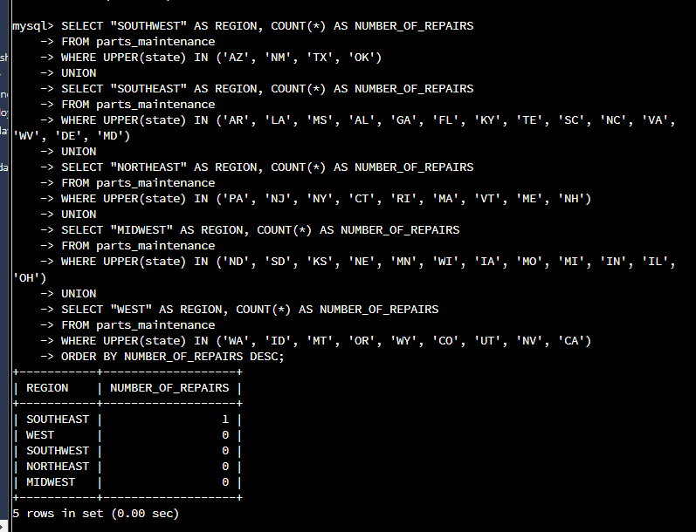

As seen with the commands: **SELECT "SOUTHWEST" AS REGION, COUNT(*) AS NUMBER_OF_REPAIRS**

**FROM parts_maintenance**

**WHERE UPPER(state) IN ('AZ', 'NM', 'TX', 'OK')**

**UNION**

**SELECT "SOUTHEAST" AS REGION, COUNT(*) AS NUMBER_OF_REPAIRS**

**FROM parts_maintenance**

**WHERE UPPER(state) IN ('AR', 'LA', 'MS', 'AL', 'GA', 'FL', 'KY', 'TE', 'SC', 'NC', 'VA', 'WV', 'DE', 'MD')**

**UNION**

**SELECT "NORTHEAST" AS REGION, COUNT(*) AS NUMBER_OF_REPAIRS**

**FROM parts_maintenance**

**WHERE UPPER(state) IN ('PA', 'NJ', 'NY', 'CT', 'RI', 'MA', 'VT', 'ME', 'NH')**

**UNION**

**SELECT "MIDWEST" AS REGION, COUNT(*) AS NUMBER_OF_REPAIRS**

**FROM parts_maintenance**

**WHERE UPPER(state) IN ('ND', 'SD', 'KS', 'NE', 'MN', 'WI', 'IA', 'MO', 'MI', 'IN', 'IL', 'OH')**

**UNION**

**SELECT "WEST" AS REGION, COUNT(*) AS NUMBER_OF_REPAIRS**

**FROM parts_maintenance**

**WHERE UPPER(state) IN ('WA', 'ID', 'MT', 'OR', 'WY', 'CO', 'UT', 'NV', 'CA')**

**ORDER BY NUMBER_OF_REPAIRS DESC;**, it is shown that the Southeast is the region that experiences more part failures and replacements than others.

* + 1. How might the fleet maintenance team use the information to update its maintenance schedule?

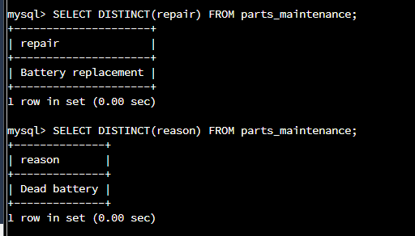

By using the commands: **SELECT DISTINCT(repair) FROM parts_maintenance;** &

**SELECT DISTINCT(reason) FROM parts_maintenance;**, I am able to determine updated information on the repair and the reason for the reason which in this case a dead battery would be good information for the maintenance schedule.

* 1. Which parts are being replaced most due to corrosion or rust?
     1. 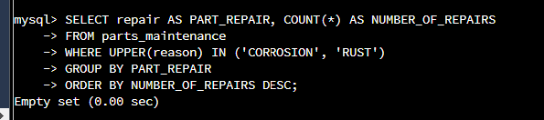

The parts that are being replaced most due to corrosion or rust are shown with the following commands: **SELECT repair AS PART_REPAIR, COUNT(*) AS NUMBER_OF_REPAIRS**

**FROM parts_maintenance**

**WHERE UPPER(reason) IN ('CORROSION', 'RUST')**

**GROUP BY PART_REPAIR**

**ORDER BY NUMBER_OF_REPAIRS DESC;**, which the result is none.

* 1. Which parts are being replaced most because of mechanical failure or accident, like a flat tire or rock through the windshield?
     1. 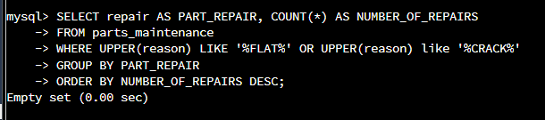

The parts being replaced most because of failure or accident, like flat tire or rock are shown with the commands: **SELECT repair AS PART_REPAIR, COUNT(*) AS NUMBER_OF_REPAIRS**

**FROM parts_maintenance**

**WHERE UPPER(reason) LIKE '%FLAT%' OR UPPER(reason) like '%CRACK%'**

**GROUP BY PART_REPAIR**

**ORDER BY NUMBER_OF_REPAIRS DESC;**, which the outcome is an empty set or none.

1. **Write a brief summary of your analysis** thattakes the information from Step 1 and presents it in a way that nontechnical stakeholders can understand.
   1. With these computer instructions for PCs and Apple, we can determine information on a car part. Information such as the type of repair, which location the repairs were made, how many repairs, and why those parts need repairs.
2. **Outline the approach** that you took to conduct the analysis.
   1. What queries did you use to identify trends or themes in the data?
      1. 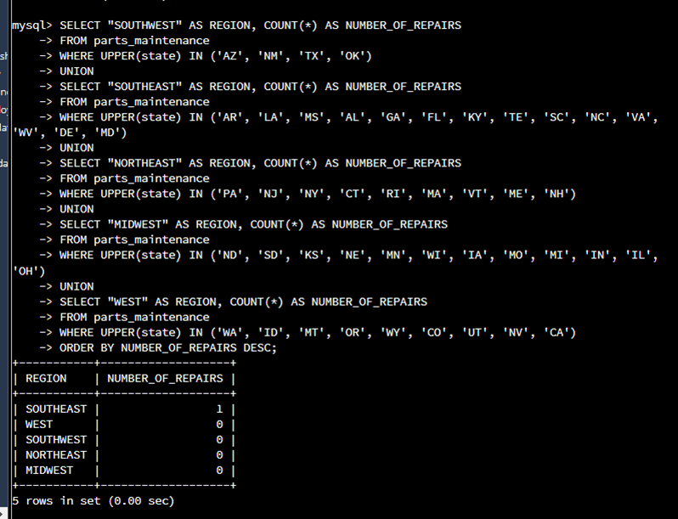

With the command: **SELECT "SOUTHWEST" AS REGION, COUNT(*) AS NUMBER_OF_REPAIRS**

**FROM parts_maintenance**

**WHERE UPPER(state) IN ('AZ', 'NM', 'TX', 'OK')**

**UNION**

**SELECT "SOUTHEAST" AS REGION, COUNT(*) AS NUMBER_OF_REPAIRS**

**FROM parts_maintenance**

**WHERE UPPER(state) IN ('AR', 'LA', 'MS', 'AL', 'GA', 'FL', 'KY', 'TE', 'SC', 'NC', 'VA', 'WV', 'DE', 'MD')**

**UNION**

**SELECT "NORTHEAST" AS REGION, COUNT(*) AS NUMBER_OF_REPAIRS**

**FROM parts_maintenance**

**WHERE UPPER(state) IN ('PA', 'NJ', 'NY', 'CT', 'RI', 'MA', 'VT', 'ME', 'NH')**

**UNION**

**SELECT "MIDWEST" AS REGION, COUNT(*) AS NUMBER_OF_REPAIRS**

**FROM parts_maintenance**

**WHERE UPPER(state) IN ('ND', 'SD', 'KS', 'NE', 'MN', 'WI', 'IA', 'MO', 'MI', 'IN', 'IL', 'OH')**

**UNION**

**SELECT "WEST" AS REGION, COUNT(*) AS NUMBER_OF_REPAIRS**

**FROM parts_maintenance**

**WHERE UPPER(state) IN ('WA', 'ID', 'MT', 'OR', 'WY', 'CO', 'UT', 'NV', 'CA')**

**ORDER BY NUMBER_OF_REPAIRS DESC;**, I was able to display the trend of battery repair in the Southeast region. Using COUNT(*) in the query is helpful in finding the number of repairs.

* 1. What are the benefits of using these queries to retrieve the information in a way that allows you to provide valuable information to your stakeholders?
     1. The benefits of using these queries to retrieve the information easily with little time consumption which can produce inexpensive costs in staff, data storage, and energy bills.

1. **Explain how the functions in the analysis tool** allowed you to organize the data and retrieve records quickly.
   1. The functions in the analysis tool allowed me to organize the data and retrieve records because I am following the rules of the machine realm. I am commanding or instructing the computer, in the terminology it understands, to give me the information however way I want it coordinated and restored. For example, when determining the region in which there are more replacements and failures than others, the regions that were searched used abbreviations. Terminology like this is used to communicate between a user and MySQL.